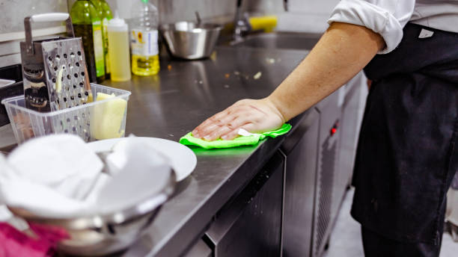  Contaminated Equipment  Cross-contamination is the unintentional transfer of bacteria from one surface to another surface. This could be from unclean hands or equipment that touch food or raw animal foods that touch or drip onto ready-to-eat foods (RTE).  Wash, rinse, and sanitize food contact surfaces using the following procedures:  - Wash the surface with a detergent solution to clean it.  - Rinse the surface with clean water to remove debris and detergent.  - Sanitize the surface using a sanitizing solution at the concentration specified on the manufacturer’s label.  - Allow items to air dry | Contaminated Equipment
  Food Contact Surfaces must be washed, rinsed, and sanitized:
  After each use.
  Anytime you begin working with another type of food.
  After the task has been interrupted, the items may have been contaminated.
  At 4-hour intervals if the items are in constant use.
  Richmond County Health Department
  127 Caroline Street
  Rockingham, NC 28379
  910-997-8329
  www.richmondnc.com/505

